**HCI PROJECT REVIEW-1**

**SUBMITTED BY:**

**P S PRANEETH**

**THEME:** **Class Attendance Management Problem**

**DESCRPITION :**

During capturing of attendance in classroom through the manual process. Most of the students try to give proxy attendance to their besties and competing classmates without their presence. At this time teacher cannot focus each and every student to verify their presence in class. This mainly leads a problem to faculty and often students as they miss their syllabus of particular subject. So Class Attendance Management can overcome this problem.

**1.Identify the target user community as Senior citizen/ Children/etc**

Ans :

Target user : Faculty

**2.Existing product design:**

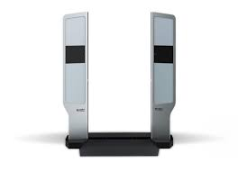 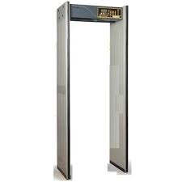

**3.Understand and list the limitations faced by the respective target user community.**

Ans:

* One student may bring his/her friend card,after he/she enters the class they may leave the class without identity card and re-enter with a new one so system cannot notify.
* It will lock within time.
* It require continuous internet connection.
* Late comers will be marked as absent.

**4.Provide a suitable list of suggestions/ solutions for the limitations found in the product’s existing HCI design.**

Ans:

* Teacher can verify attendance by counting number of students present in class.
* We can setup the software to capture attendance and lock it after faculty entering into the classroom.
* It should be connected with the college wireless or data network.
* When faculty(admin) enters into class attendance will be partially locked. After class completion and faculty exit it will updated into login. During this time Teacher can manipulate attendance.